**ASSISTED PRACTICE (PROCESSORS, ASSERTIONS AND TIMERS)**

Processors:

Step1: Open Jmeter -> Add Thread Group

Step2: Right click on Thread Group -> Add -> Sampler -> HTTP request

Step3: In HTTP request, Give “https” as Protocol, Give “blazedemo.com” as Server, Give “/” as Path

Step4: Right click on HTTP request -> Add -> Post Processors -> Regular Expression Extractor

Step5: In Regular Expression Extractor, Give “city” as Name of created variable, Give “<option value="(.*?)">(.*?)</option” as Regular Expression, Give “$1$” as Template, Give “-1” as Match Number, Give “City not Found” as Default value

Step6: Right click on Thread Group -> Add -> Logic Controller -> For Each Controller

Step7: In For Each Controller, Give “city” as Input variable prefix, Give “1” as Start index for loop, Give “${city_matchNr}” as End index for loop -> Give “eachCity” as Output variable name

Step8: Right click on For Each Controller -> Add -> Sampler -> Dummy Sampler -> Give the name of Dummy Sampler as “The city name is -${eachCity}” (To install the Dummy Sampler -> Go to options of Jmeter -> Click On Plugin manager -> Available plugins -> Search for Dummy Sampler and install it(select the checkbox) -> Once it has been installed, Click on “Apply changes and restart jmeter” at the bottom of this window -> Jmeter will restart )

Step9: Right click on Thread Group -> Add -> Listener -> View results tree (to see the output)

Step10: Right click on Thread Group -> Add -> Sampler -> Debug Sampler

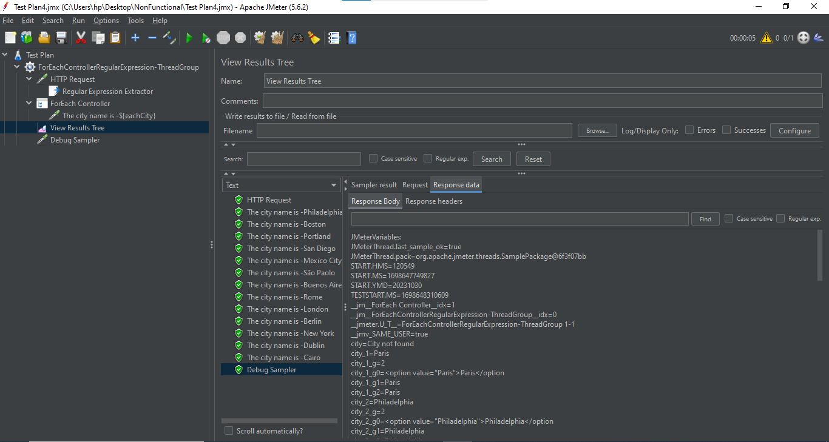

**ASSERTIONS:**

1. Response Assertion

Step1: Right click on Junit request(in junit sampler) -> Add -> Assertions -> Response Assertion

Step2: In “Field to Test” Section -> Select the checkbox “Response code”

Step3: Click on Add at the bottom -> Double click on “Patterns to Test” section -> Enter Expected value in this section(Failure code – 0001) -> Save it

Step4: Right Click on Thread Group -> Add -> Listener -> Assertion results

Step5: Now, Execute this code to see the output :

In “View Results Tree” :

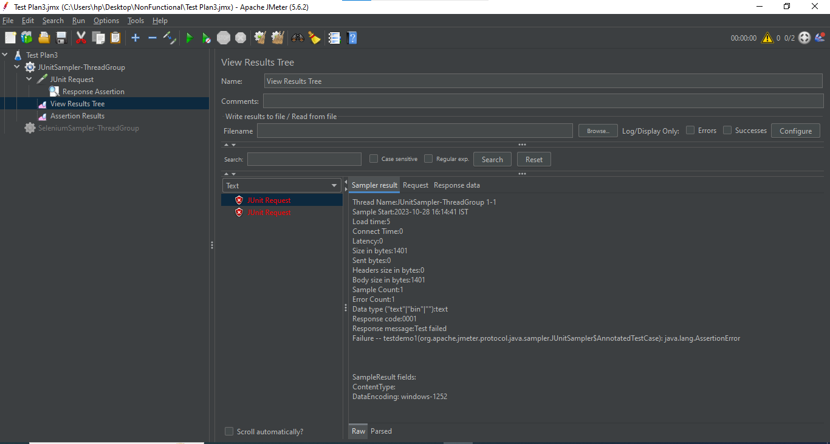

In Assertion Results:

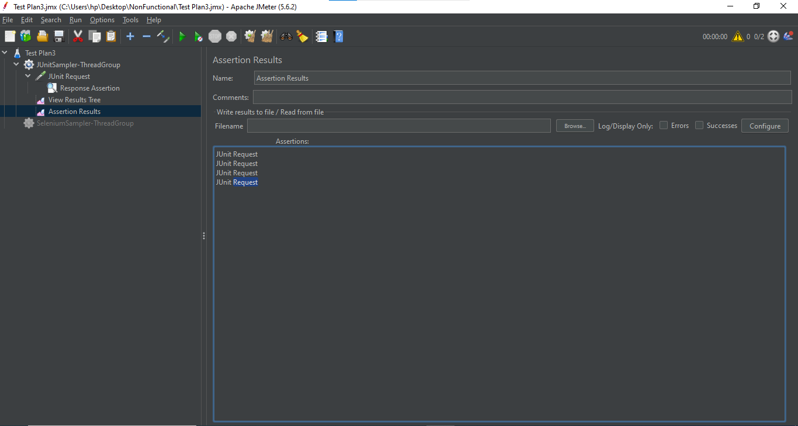

1. HTML Assertion:

Step1: Open Jmeter -> Add Thread Group to Test Plan

Step2: Right click on Thread Group -> Add -> Sampler -> HTTP request

Step3: In HTTP request -> Give protocol as “https” -> Server as “blazedemo.com” -> Path as “/”

Step4: Right click on HTTP request -> Add -> Assertions -> HTML Assertion

Step5: In HTML Assertion -> Browse the file name where we have to save the errors of website -> Go to our desktop folder where we saved the Test Plans -> Create another folder in that folder and give any name to this folder -> In this, save the file name as e.g.(errors.txt) -> Save it

Step6: Right click on Thread Group -> Add -> Listener -> View Results Tree

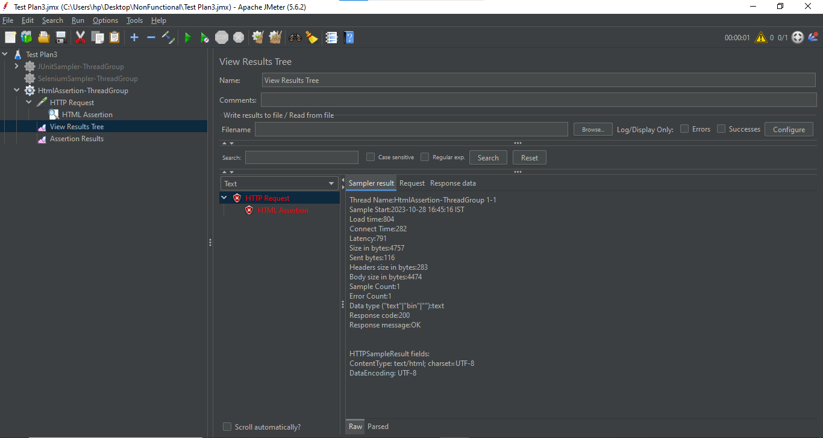

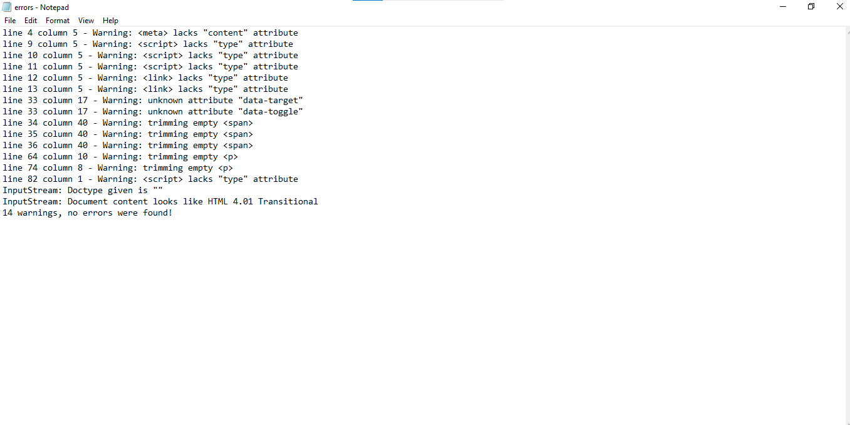

Step7: Right click on Thread Group -> Add -> Listener -> Assertion Result

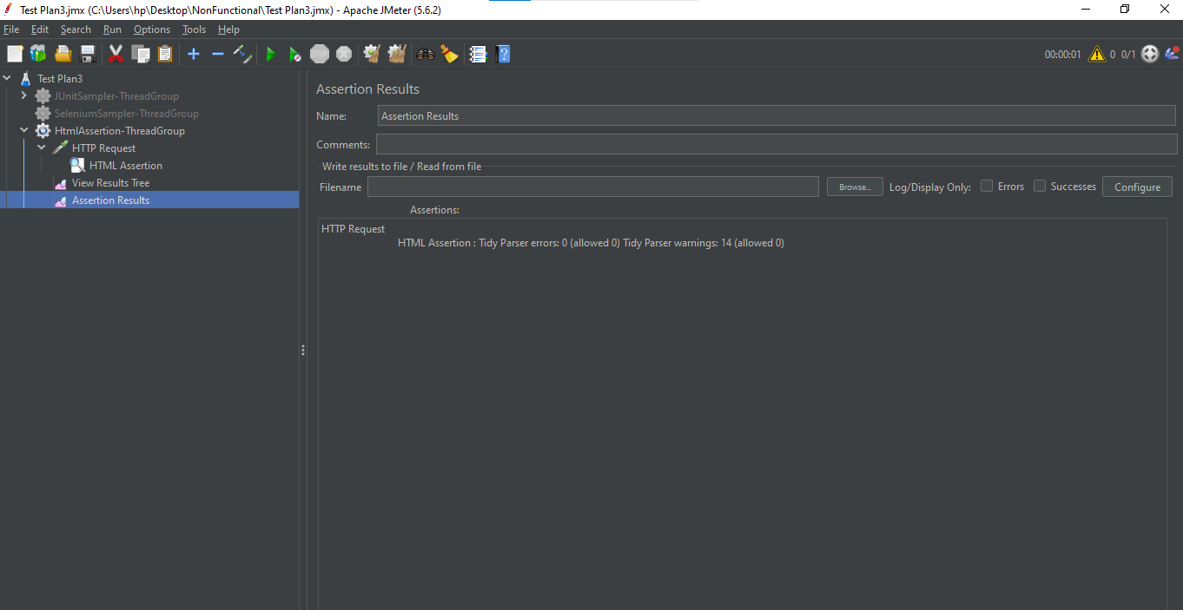

1. XML Assertion:

Step1: Open Jmeter -> Add Thread Group

Step2: Right click on Thread Group -> Add -> Sampler -> HTTP request

Step3: In HTTP request -> Give protocol as “https” -> Server as “[www.w3schools.com](http://www.w3schools.com)” -> Path as “/xml/note.xml

Step4: Right click on HTTP request -> Add -> Assertions -> XML Assertion

Step5: Right click on Thread Group -> Add -> Listener -> View Results Tree (to see the output) as shown below:

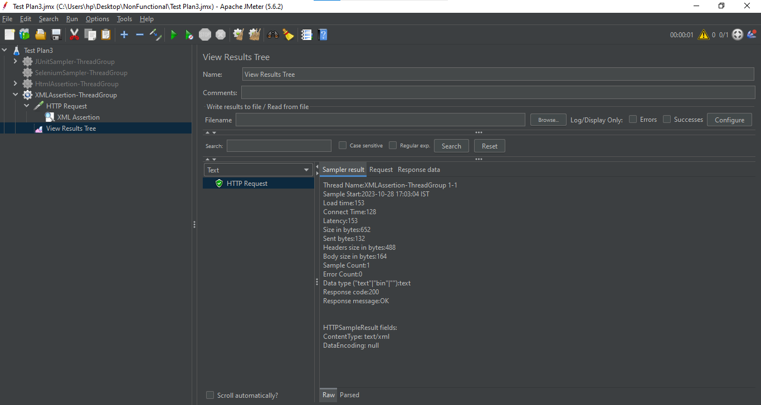

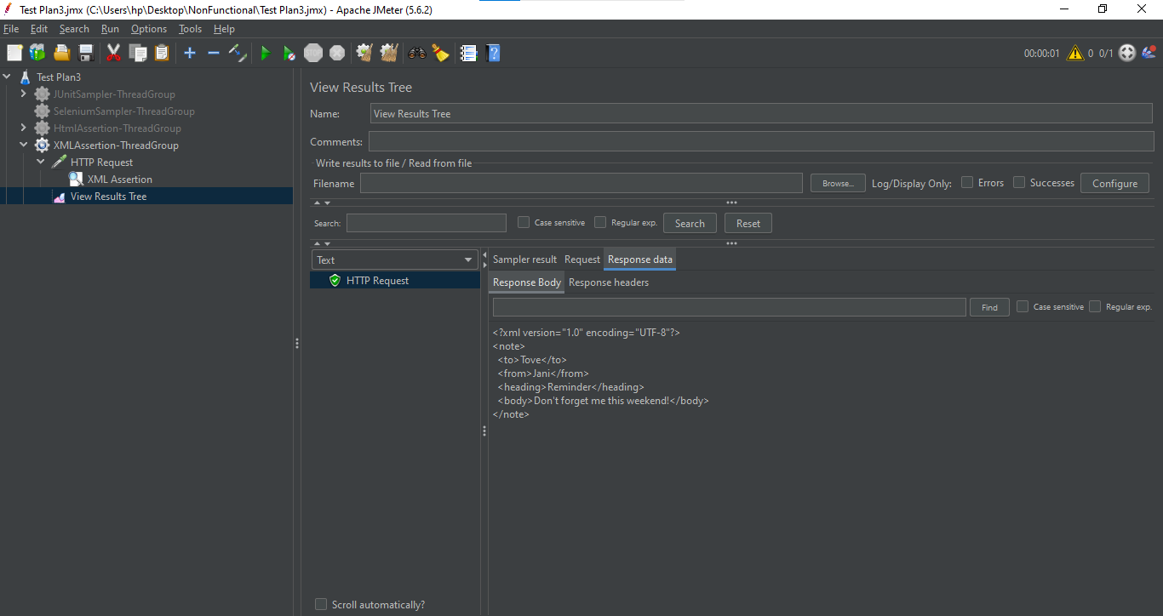

1. XML Schema Assertion:

Step1: Take this xml schema of “www.w3schools.com” website:

<note>

<to>Tove</to>

<from>Jani</from>

<heading>Reminder</heading>

<body>Don’t forget me this weekend!</body>

Step2: Generate this xml schema from xml

Step3: Go to google and search for “Generate xml schema from xml” and press enter

Step4: Select the free online converter for this conversion

Step5: Generate schema

Step6: Take this schema -> Copy in notepad -> Save this file in (our apache jmeter folder -> bin -> examples -> Save the file in this examples folder with the name “sampledemo.xsd”

Step7: Start Jmeter

Step8: Right click on HTTP request that we have created in XML assertion -> Add -> Assertions -> XML Schema Assertion

Step9: Give the complete path of our notepad file (sampledemo.xsd) in XML Schema Assertion -> Save it

Step10: Right click on Thread Group -> Add -> Listener -> View Results Tree (to see the output) as shown below:

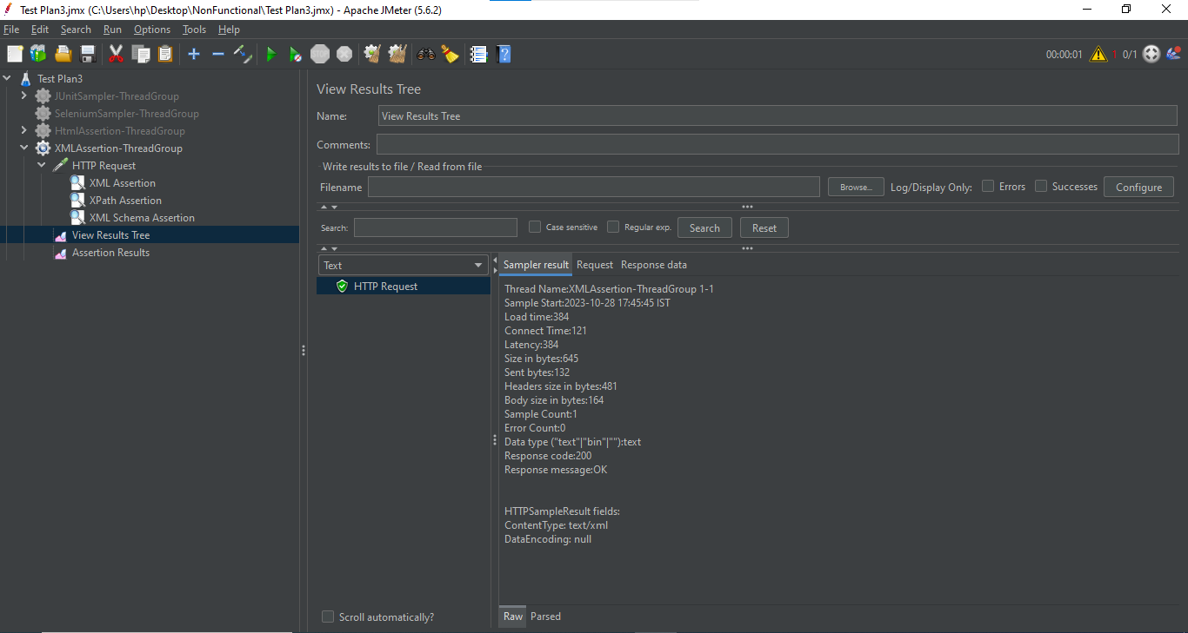

Step11: Right click on Thread Group -> Add -> Listener -> Assertion result (to see the output) as shown below:

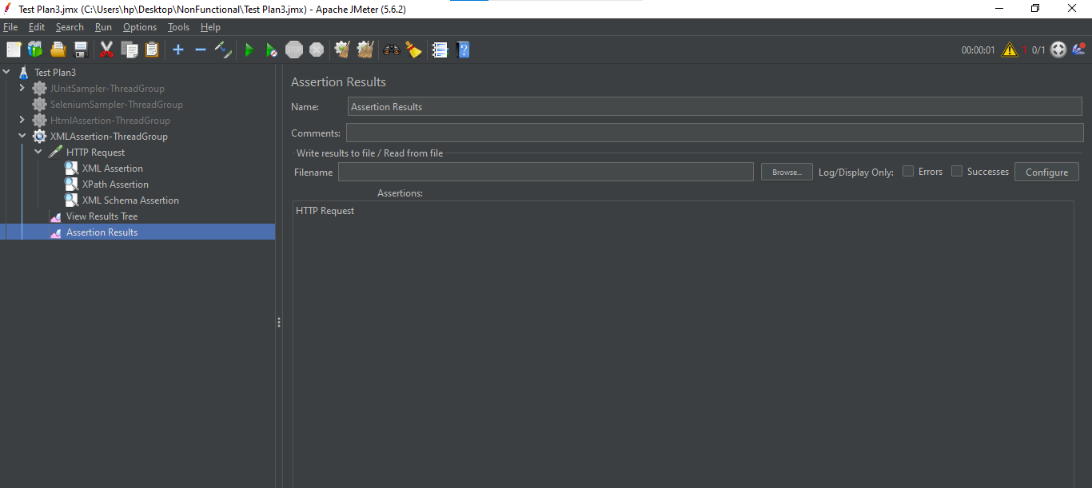

1. Xpath Assertion:

Step1: Open Jmeter

Step2: Right click on HTTP request that we have created in XML Assertion -> Add -> Assertions -> Xpath Assertion

Step3: In Xpath Assertion -> Give “/note/from” in Validate Xpath Assertion section -> Save it

Step4: Execute it to see the output

In View Results Tree:

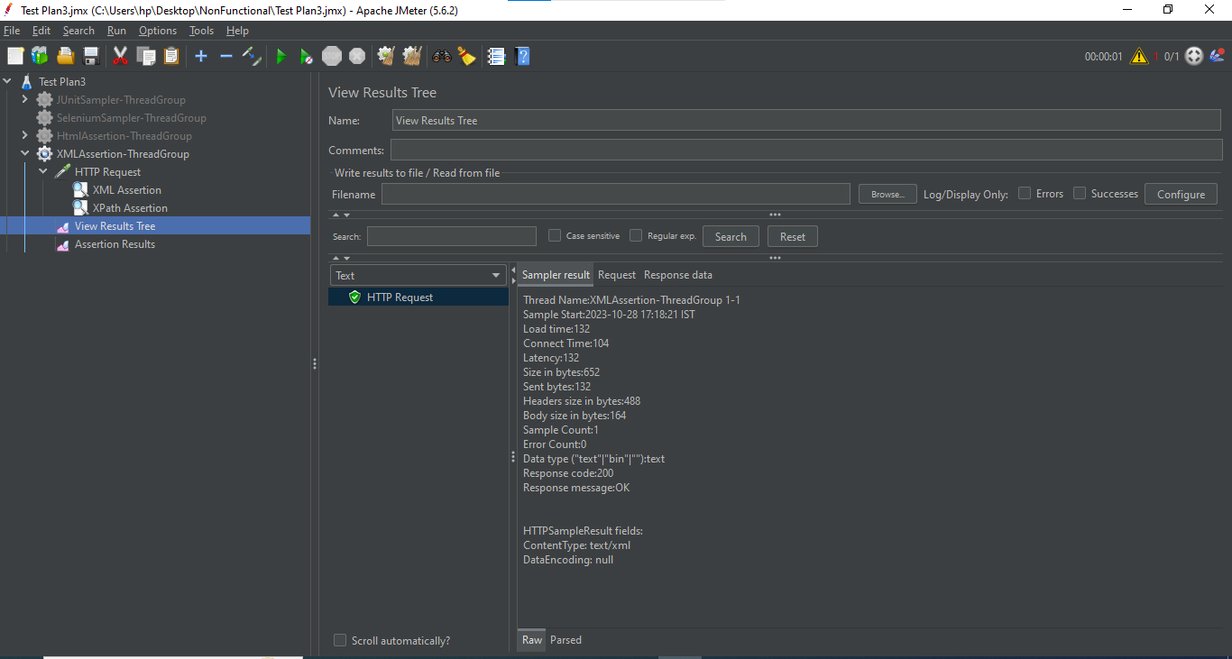

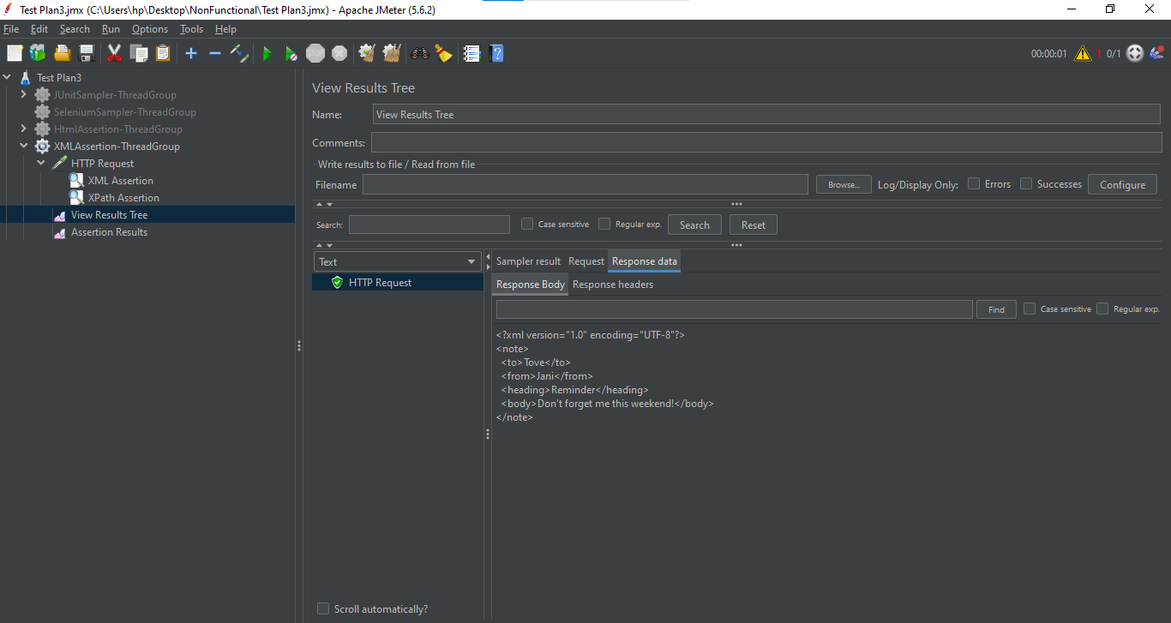

In Assertion Results:

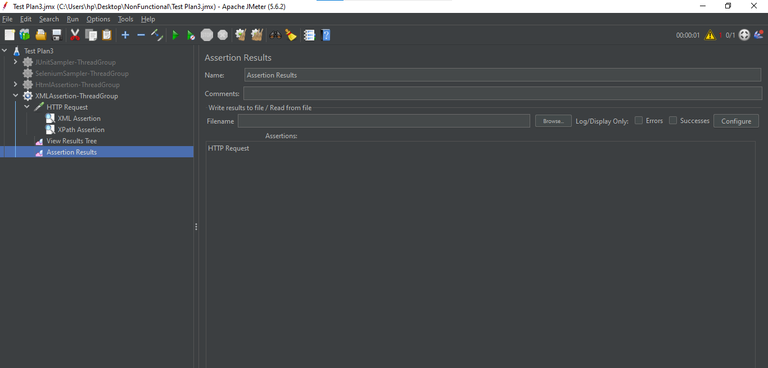

1. Comparison Assertion:

Step1: Open Jmeter -> Add Thread Group

Step2: Right click on Thread Group -> Add -> Sampler -> Add two HTTP request in this Thread Group

Step3: In both HTTP request -> Give protocol as “https” and server as “[www.google.com](http://www.google.com)”

Step4: Right click on Thread Group -> Add -> Assertions -> Compare Assertion

Step5: Right click on Thread Group -> Add -> Listener -> View Results Tree

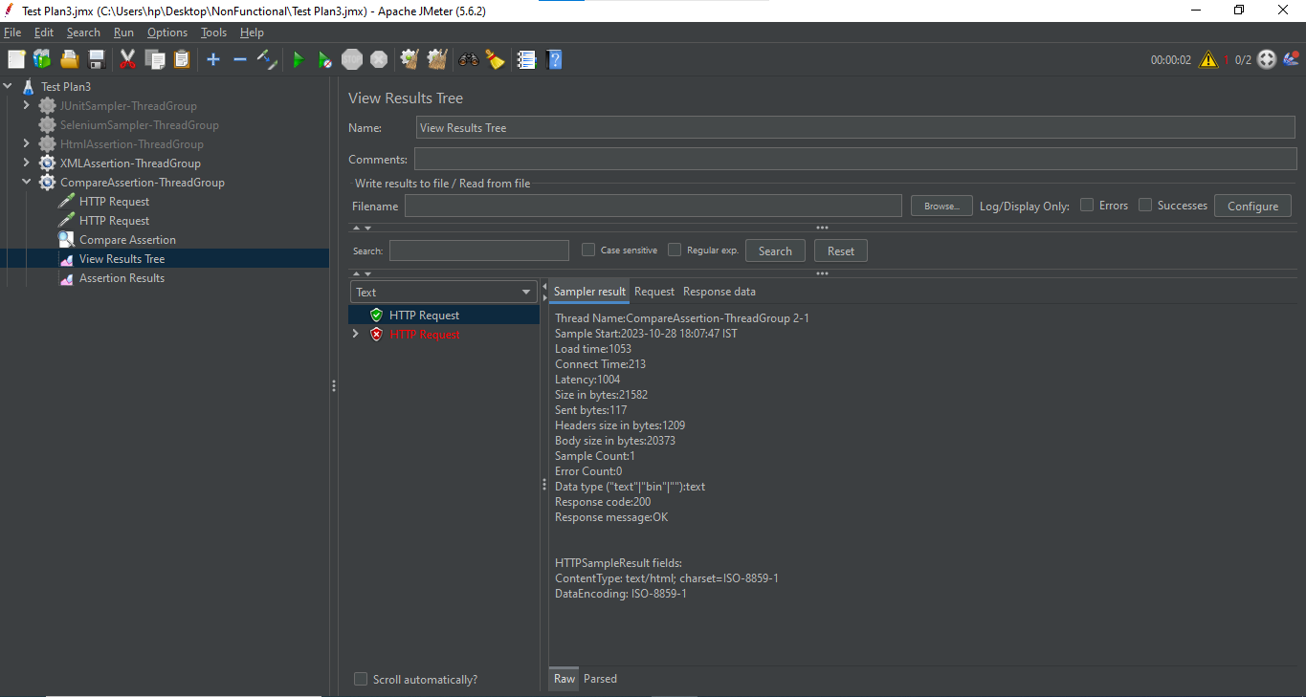

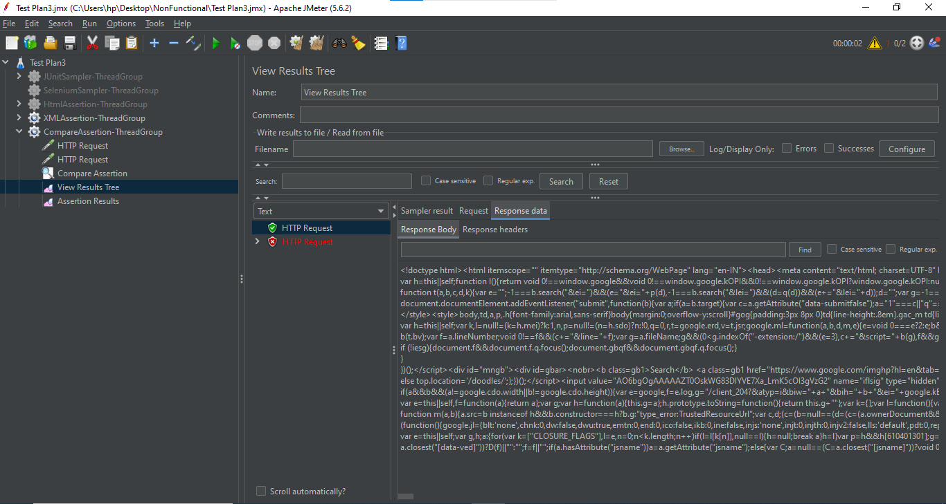

Step6: Right click on Thread Group -> Add -> Listener -> Assertion result

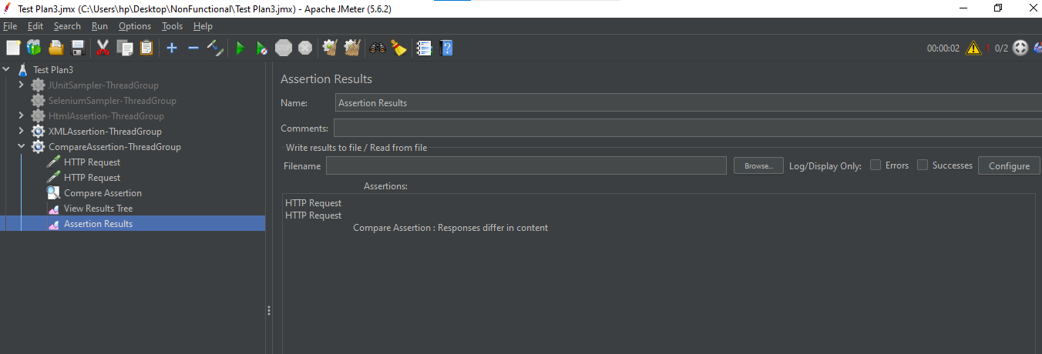

Step7: Right click on Thread Group -> Add -> Listener -> Comparison Assertion visualize

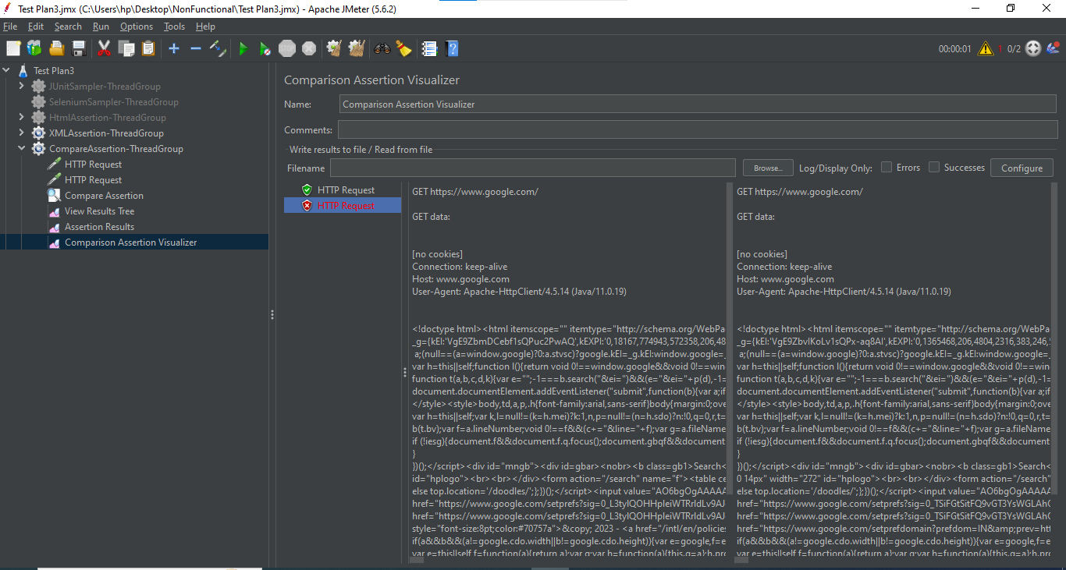

Timers:

1. Constant Timer:

Step1: Open Jmeter -> Add Thread Group

Step2: Right click on Thread Group -> Add -> Sampler -> Add Three HTTP Requests

Step3: In 1st HTTP Request, Give the details as shown below:

We have added the Time function in HTTP Request name to see the time with output

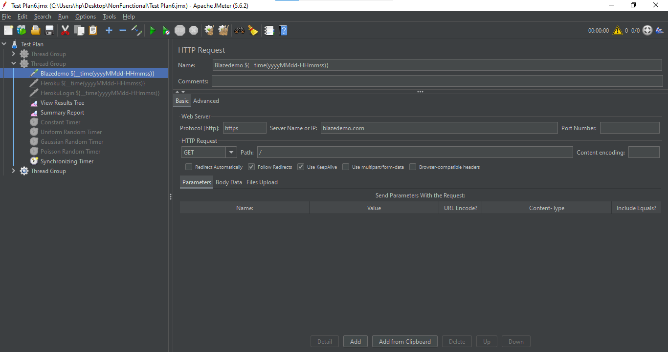

Step4: In 2nd HTTP Request, Give the details as shown below:

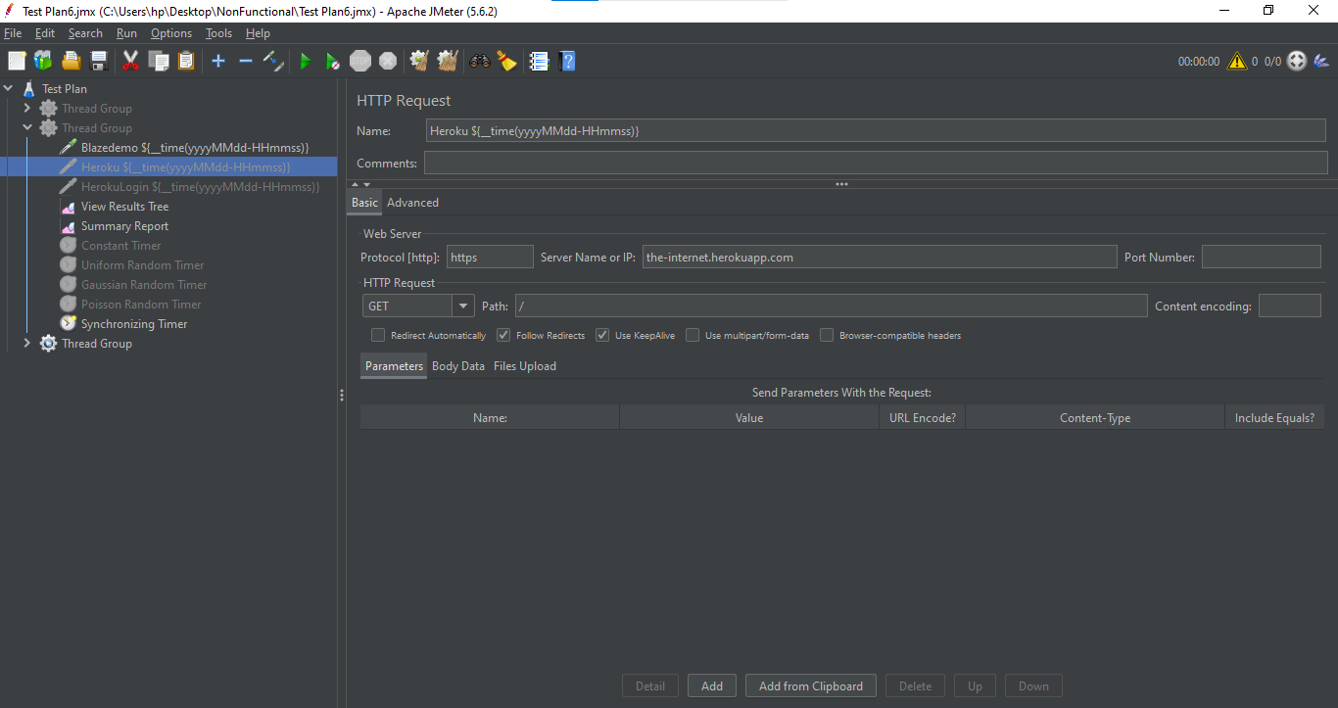

Step5: In 3rd HTTP Request, Give the details as shown below:

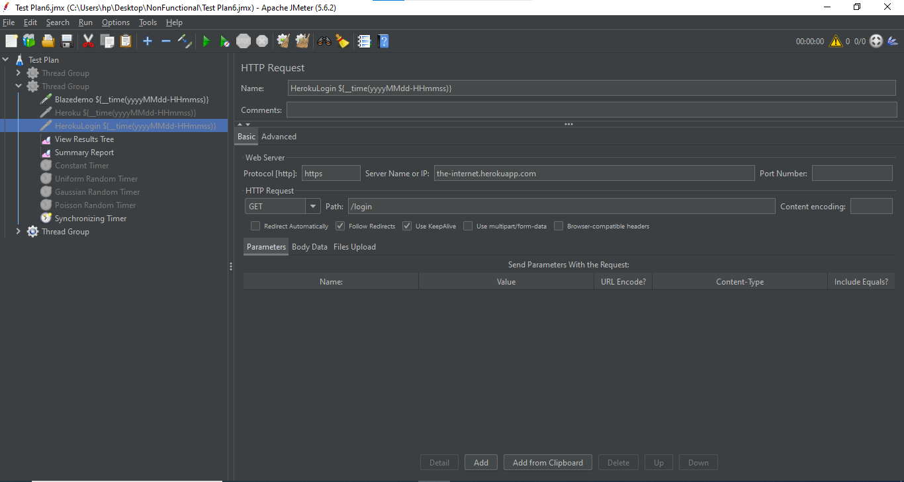

Step6: Right click on Thread Group -> Add -> Timer -> Constant Timer

Step7: In Constant Timer, Give the Thread delay as 300 milliseconds

Step8: Right click on Thread Group -> Add -> Listener -> View Results tree (to see the output)

Step9: Right click on Thread Group -> Add -> Listener -> Summary Report (to see the report of output)

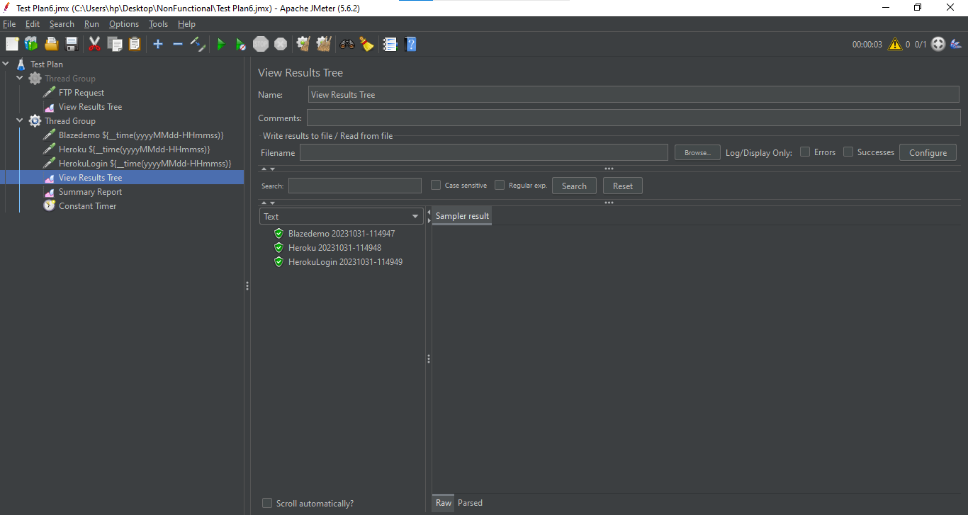

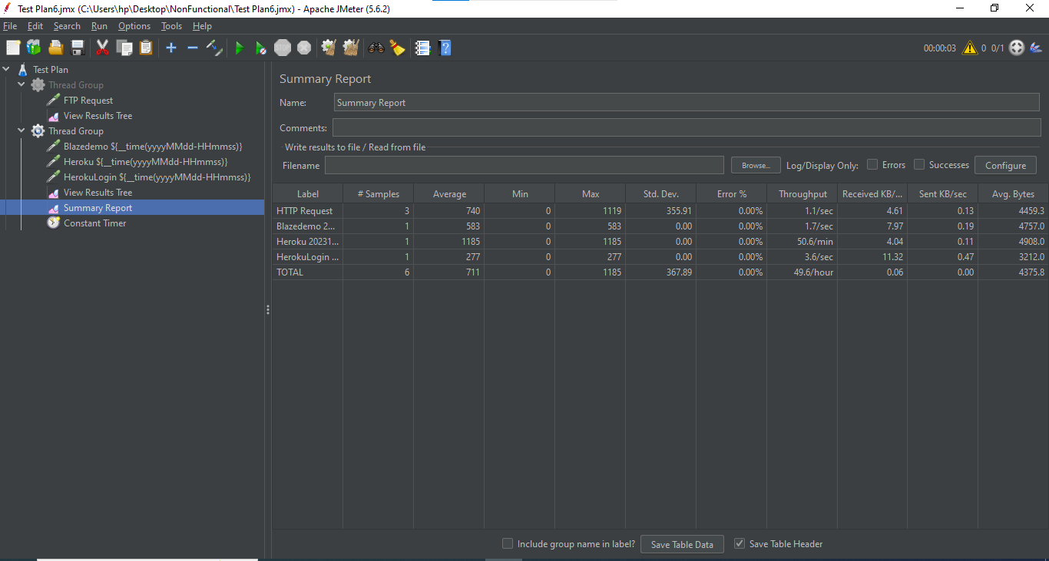

1. Gaussian Timer:

Step1: Take the same Thread Group as of Constant Timer

Step2: Disable the Constant Timer

Step3: Right click on Thread Group -> Add -> Timer -> Gaussian Random Timer

Step4: In Gaussian Random Timer -> Give the Deviation as (1000 milliseconds) -> Give the Constant Delay Offset as (3000 milliseconds)

Step5: Save it and execute it to see the Output

In View Results Tree:

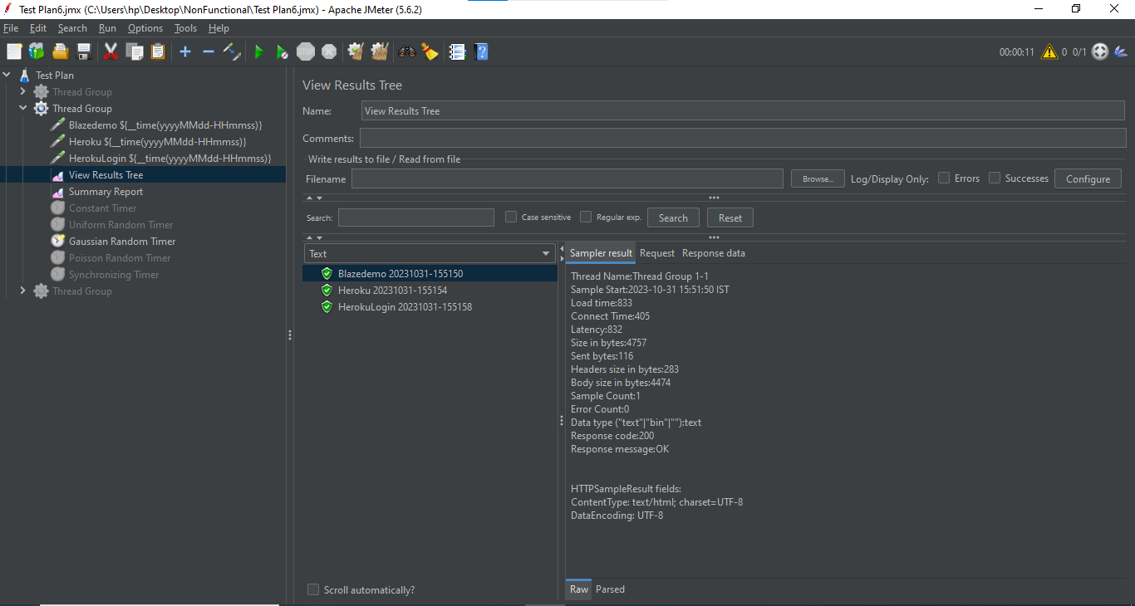

Summary Report:

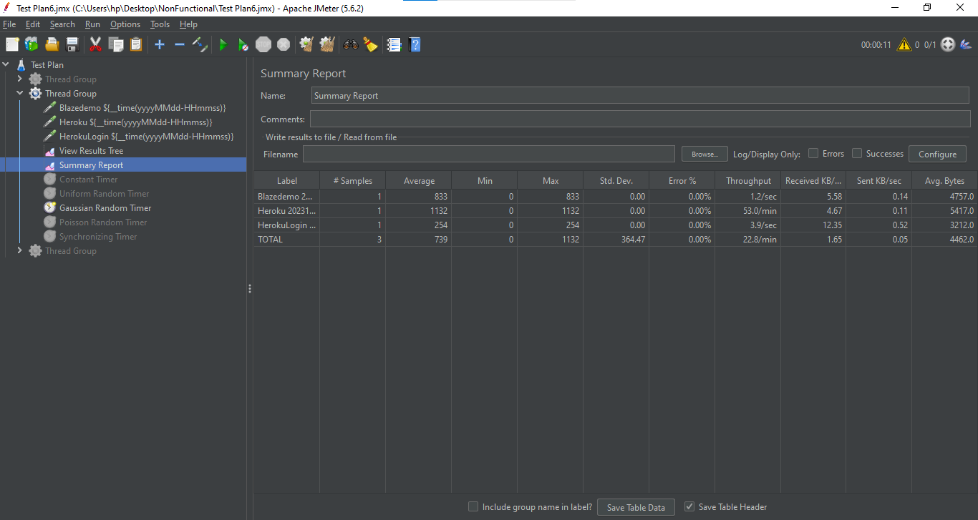

1. Poisson Timer:

Step1: Take the same Thread Group as of Constant Timer

Step2: Disable the Constant Timer and Gaussian Timer

Step3: Right click on Thread Group -> Add -> Timer -> Poisson Random Timer

Step4: In Poisson Random Timer -> Give the Lambda as (1000 milliseconds) -> Give the Constant Delay Offset as (3000 milliseconds)

Step5: Save it and execute it to see the Output

In View Results Tree:

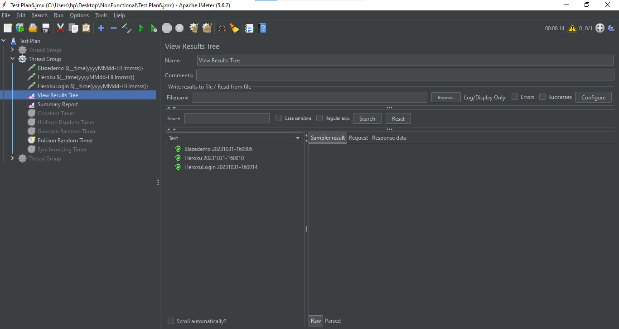

Summary Report:

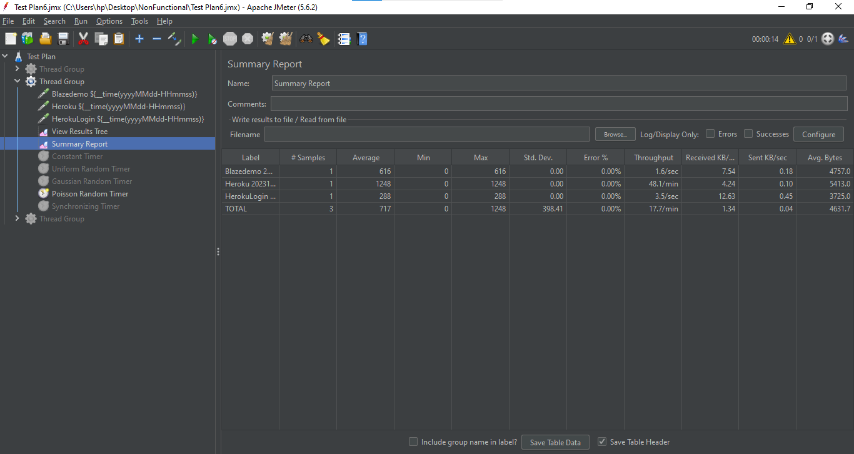

1. Synchronizing Timer:

Step1: Take the same Thread Group as of Constant Timer

Step2: In Thread Group, Give the values as shown below:

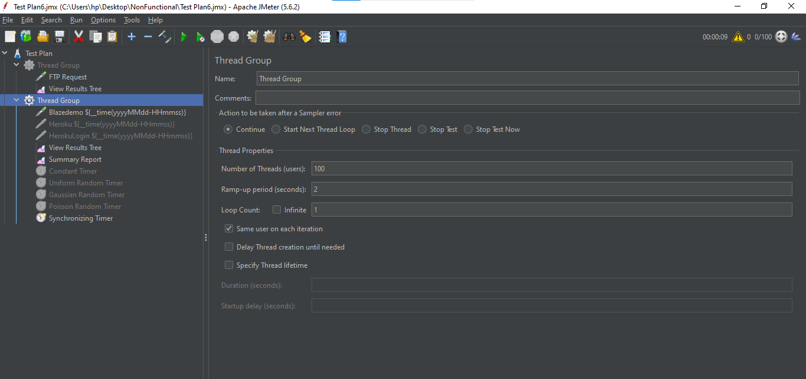

Step3: Disable all the previously added Timers -> Also disable second and third HTTP Request

Step4: Right click on Thread Group -> Add -> Timer -> Synchronizing Timer

Step5: In Synchronizing Timer, Give the values as shown below:

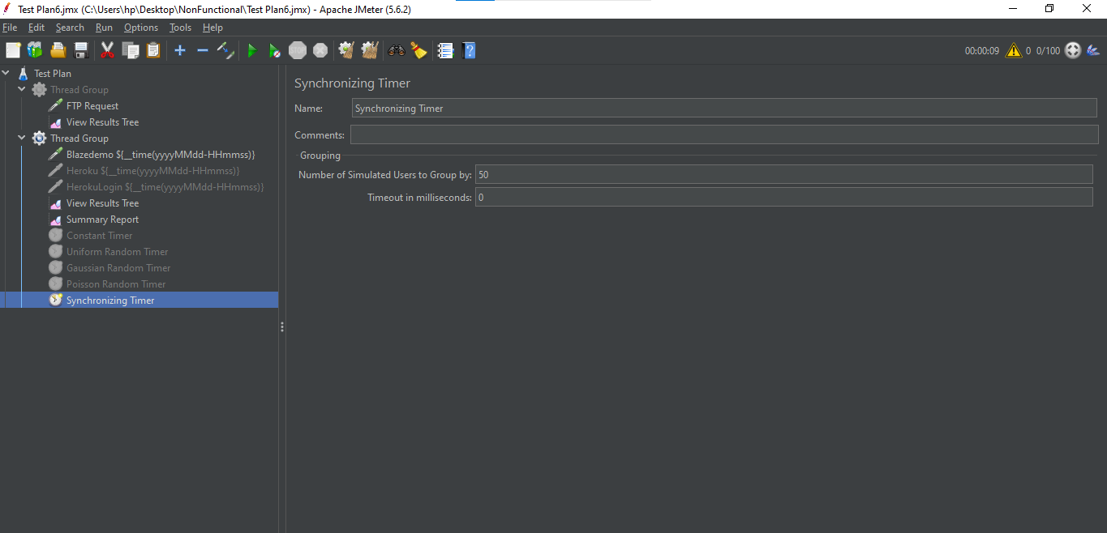

Step6: Save it and execute to see the output

In View Results Tree:

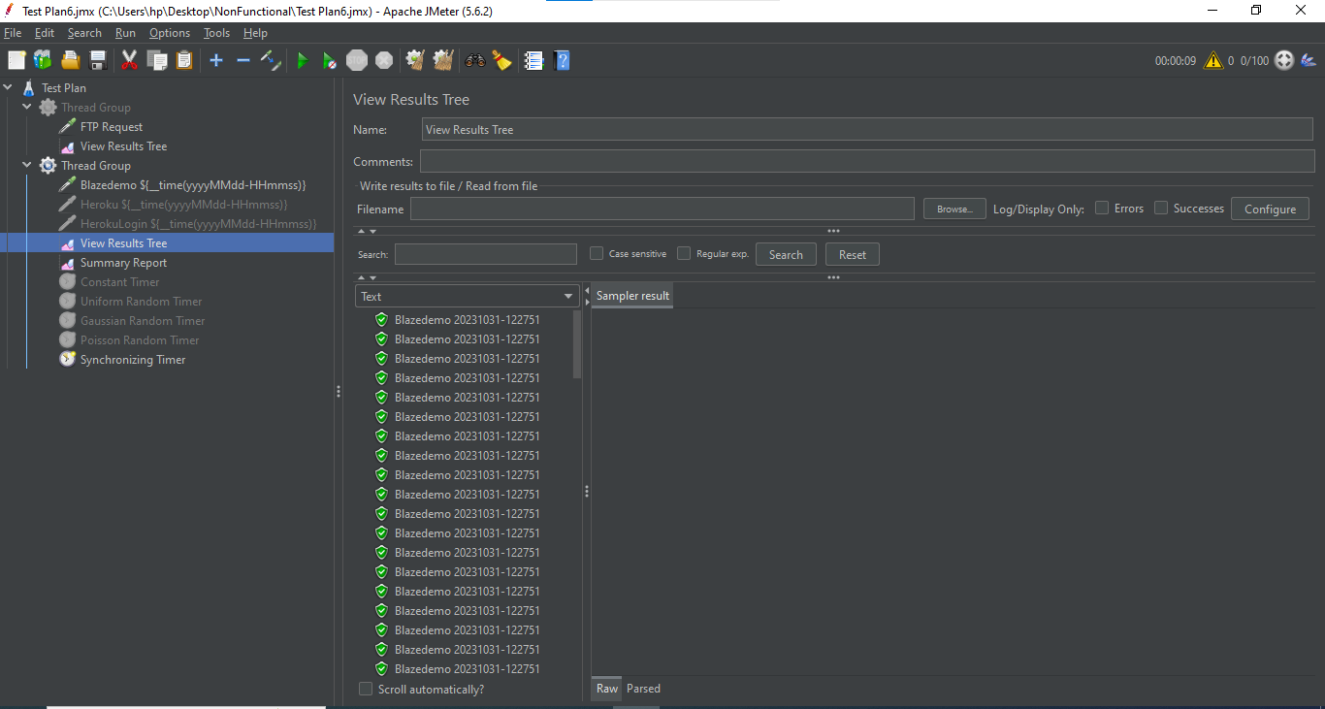

Summary Report:

